# **Question 1**

*Three identical, constant pitch thin helical coils (having the pitch* ***p****, the number of turns* ***N*** *and inner diameter* ***d****) are positioned with their axis along three rectangular (cartesian) coordinates Ox, Oy and Oz at the same distance* ***a*** *from the origin O. All three coils generate a magnetic flux density directed towards the origin O, when powered by the same DC current* ***I****.*

1. *Calculate the magnetic flux produced at the origin by one of the coils.*

Firstly, a function called ‘bhelical’ which calculates the magnetic flux density at a point zp from the origin of a thin helical coil, using the equation for ‘B’ shown below was created. The function takes the inputs of coil radius, number of turns, length, current and distance from the axis zp.

$$Z_{p}=a+\frac{length of coil}{2}$$

$$B=\frac{μ_{0}NI}{2L}\left[\frac{Z_{p}+L/2}{\sqrt{a^{2}+{(Z_{p}+\frac{L}{2})}^{2}}}-\frac{Z_{p}-L/2}{\sqrt{a^{2}+{(Z_{p}-\frac{L}{2})}^{2}}}\right]$$

This function was used to calculate the magnetic flux density at the origin of the 3 axis and was implemented in matlab as shown in figure 1. This produced a result of magnetic flux density at the origin from one coil as **0.758mT**.

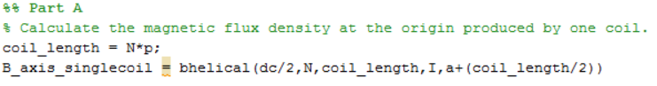

Figure 1: Part A MATLAB Input

1. *Calculate the total magnetic flux density produced at the origin by three coils.*

To calculate the resultant magnetic flux density at the origin from all three coils the vectors produced by each coil are resolved into one. This is done using Pythagoras’ theorem applied to the vectors of two coils and then applying the theorem again to produce the resultant vector. This formula can be simplified to the square root of the sum of the magnitude of each vector squared.

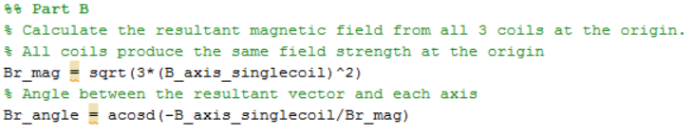

Figure 2: Part B MATLAB Input

The magnitude of the resultant vector in shown in figure 2 and produces a value of 0.0013T. As the resultant is a vector quantity it also has a direction. The angle between the resultant vector and each axis is approximately 125 degrees.

1. *Calculate the total field when one of the coils is energised such that it generates a magnetic flux density directed opposite to the origin.*

Energising one of the coils in the opposite direction reverses the direction of the magnetic flux density produced at the origin. Applying Pythagoras’ method to the vectors in the same way as done in part b produces the same magnitude for the resultant vector. Therefore energising a coil in the opposite direction does not affect the magnitude of the resultant field. However, the direction of the resultant vector is changed such that the angle between the vector and the axis on which the coil is situated is changes to 54.7 degrees.

1. *Draw accurately the magnetic flux density generated by one coil along its axis.*

Using the function described in part a, the magnetic field is calculted for an array of zp values as show in figure 3. Figure 4 shows the magnetic flux density in the centre of the coil as a homogenous field strength with the field strength decreasing rapidly until point of x = 0.03 (end of coil) where the field strength decrease exponentially.

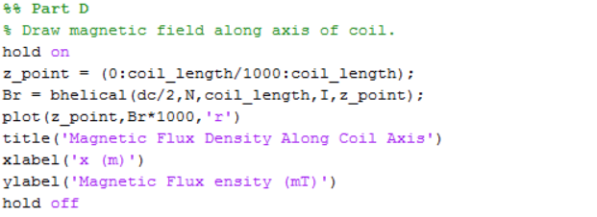

Figure 3: Part D MATLAB Code

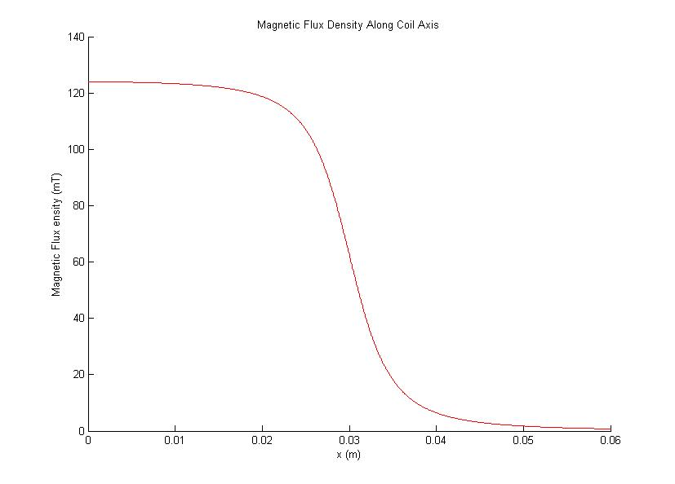

Figure 4: Magnetic Flux Density along coil axis.

# **Question 2**

*Two circular coils having a common axis are separated in air by a distance* ***x****. Coil 1 has* ***N1*** *turns and a large mean radius* ***R1****. Coil 2 has* ***N2*** *turns and a very small mean radius* ***R2****. The current flowing through the coils are* ***I1*** *and* ***I2****.*

1. *Calculate the resultant magnetic flux density generated by the two coils on axis at a point midway between them when the two currents are flowing:*
2. *In the same direction.*

Using the equation detailed below the magnetic field flux density produced by coil 1 between the two coils is calculated first. Secondly the flux density at the same point produced by coil 2 is calculated. As the currents are flowing in the same direction, both magnetic flux vectors will have the same direction components, as such, the resultant field is the sum of the two magnetic fluxes and produces a result of **0.303mT**.

$$B=\frac{μ_{0}x^{2}I}{2{(a^{2}+z^{2})}^{3/2}}$$

1. *In opposite directions.*

With the currents in the opposite direction the total magnetic flux is the difference between the magnetic fields produced by coil 1 and coil 2. The result of this is **0.271mT**.

1. *Calculate the magnetic flux density produced by coil 1 at distance x along its axis. Use this value to estimate the mutual inductance between the two coils.*

Using the equation above to calculate the field produced by coil 1 produces a result of **0.225mT** at a distance of 0.1m from coil 1. The equation below is used to estimate the mutual inductance between the two coils, where $ϕ_{12}$ is B as calculate above multiplied by the area of coil 2.

$$M_{12}=\frac{{N_{2}}^{2}}{I_{1}}ϕ_{12}$$

This produces an estimate of the mutual inductance as **1.89nH**.

1. *Calculate the two components (radial and axial) of the magnetic flux density produced by coil 1 at a point simulated on coil 2.*

The following equations are written into a function that calculates the two components of magnetic flux that act on a point off axis to a coil.

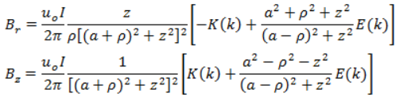

This produces a result of Br = **-0.372mT** ad a value of Bz = **0.228mT.**

1. *Calculate the two components (radial and axial) of the magnetic flux density produced by coil 2 at a point simulated on coil 1.*

The same method as part c is used to calculate the two components is used. The values of Br ad Bz are expected to be smaller that that of part c as radius d coil 2 is much smaller than that of coil 1. This produces a result of Br = **-14.9µT** and a value of Bz = **29.9µT**.

1. *Calculate the mutual inductance between the two coils. Compare this result with te estimate obtained in (b) and comment.*

The following matlab code calculates the mutual inductance between the two coils. There is a discrepancy between the results in b and e because the equation used in part b is an estimate between two circuits of unspecified size and axial distances. However, the equation used in part e is based on two circular loops that have a common axis between them.

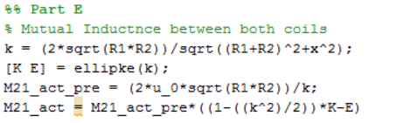

Figure 5: MATLAB Code

The code above produces an inductance of **47.1nH**.

# **Question 3**

*Three identical constant pitch thin helical coils are positioned along a common axis. The axial distance between the first and second is* ***Z1****, the distance between the second and third is* ***Z2*** *and the distance between the first and third is* ***Z3*** *=* ***Z1****+****Z2****+****L****.*

1. *Calculate the self-inductance of each of the three coils.*

As all three coils share the same properties, the inductance of each coil will be the same. This is calculated using the equation below where K is a correction factor, and is written as a function in matlab. This function, when given the inputs as defined I the question produces a result of **18.9µH**.

$$L=\frac{µ_{0}{πN}^{2}a^{2}}{l}K\left(a,l\right)$$

$$K_{long}=\frac{l}{l+0.9a}$$

$$K_{short}=\frac{l}{\frac{11}{10}l+0.8a}$$

1. *Calculate the mutual inductance between all pairs of coils i.e, M12, M13 and M23.*

The equation below is used to calculate the mutual inductance between each pair of coils where; $L_{123}$ is a theoretical coil of a length $Z_{1}$ + $Z_{2}$ + $L$.

$$M_{12}=\frac{1}{2}(L_{123}+L_{3}-L_{13}-L_{23})$$

The code below shows the calculations for $M_{12},M_{13},M_{23}$;

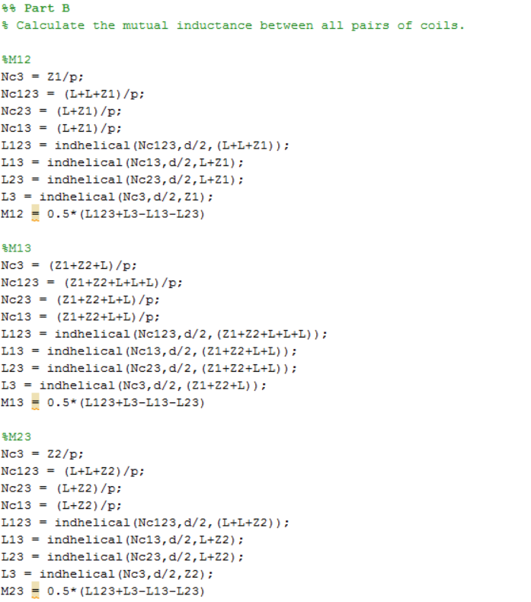

Figure 6: MATLAB Code

This produces results for $M_{12}$ = **12.2nH**, $M_{13}$ = **22.3nH**, $M_{23}$ = **14.2nH**

1. *Calculate the total effective inductance of the system made from three coils connected in series, if all oils are generating magnetic fields in the same direction.*

The total inductance of the system can be calculated using the following matlab code. This produces a result of **0.569µH**.

# **Question 4**

1. *Draw, using an electrostatic solver, the electric field distribution inside a parallel-plate capacitor charged to V=1V. For simplicity, consider each metallic plate as a t=3mm thick, D = 40mm diameter disc. The distance between plates is d=20mm and the space between them is filled with a plastic of relative permeability $ε_{r}$ = 2.4.*

In Maxwell the parallel plate capacitor is drawn such that the diameter or the disc on screen is half of the diameter described above. The final image is shown below;

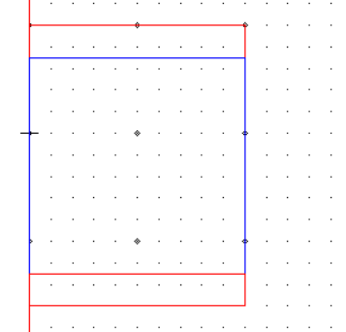

Figure 7: Parallel Plate Capacitor in Maxwell.

1. *Compare the central value of the electric field inside the capacitor with the field simply estimated as E=V/d.*

The image below show the field strength between the parallel plates of the capacitor. From the image the central field can be estimated as **43V/m** compared to the estimate of **50V/m** using the equation E=V/d. The variation in these alues is caused by the Maxwell program taking into account the material that the plates are made from and the permittivity of the material between the plates.

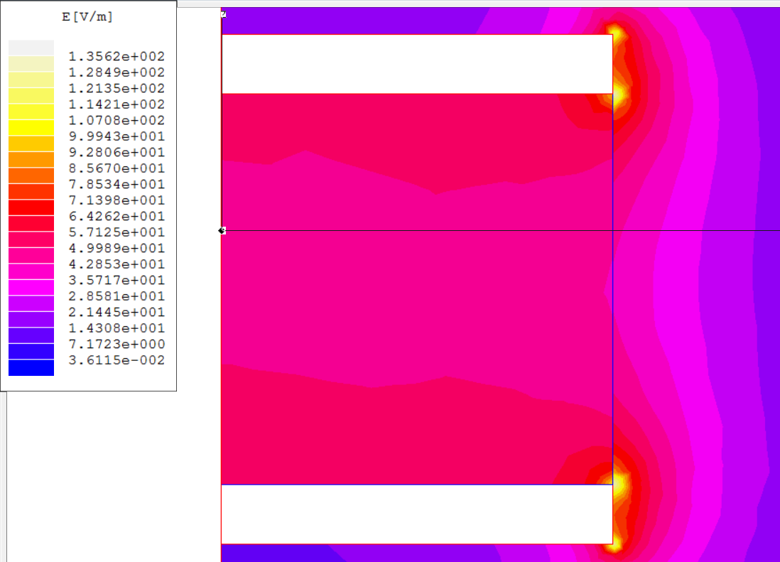

Figure 8: Maxwell plot of electric field strength.

1. *Using the result obtained in a to perform a zoom onto the triple point region and find the electric field strength at this point. Use this value to estimate the field enhancement factor with respect to the central field. Suggest a solution to lower the field in the ripple-point region.*

Performing a zoom in the triple point region produces the figure shown below and results in a maximum field strength of approximately **128.5V/m**. From this the field enhancement factor is 2.99. To lower the field in the triple-point region the edges of the plates and the plastic can be rounded. This will reduce edge effects of fringing by distributing the electric field uniformly along an edge of the conductors.

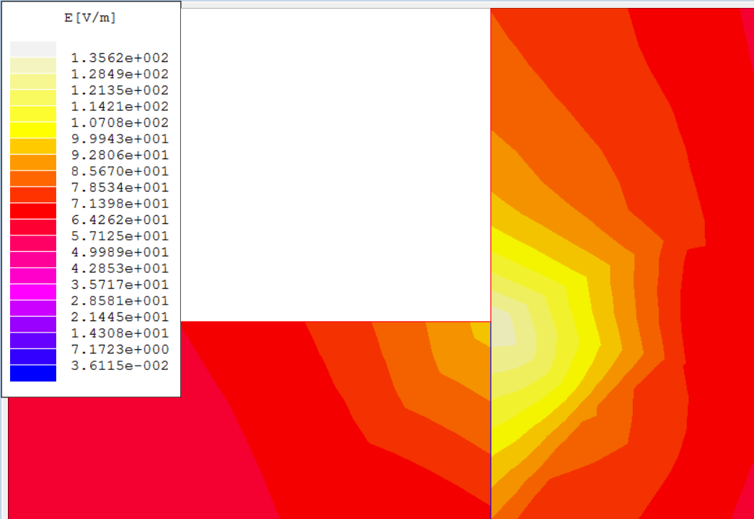

Figure 9: Maxwell Triple-Point region plot

1. *Estimate the capacitance of the capacitor using the standard formula provided in the Lecture Notes and compare it with the value offered by the electrostatic solver.*

From the equation shown below the estimated capacitance is **1.34pF**. Compared to the value calculated by Maxwell of **2.18pF**, the value generated by the electrostatic solver is different to that estimated from the equation because they use different methods to calculate capacitance. The Maxwell method takes into account the material that the plates are made from and their geometric shapes.

# **Question 5**

*Draw an equivalent circuit of the system comprising of a pair of single turn coils attached to a parallel plate transmission line and estimate its equivalent self-inductance.*

The image on the following page shows the equivalent circuit of the system described above.

To calculate the equivalent self-inductance the system was split into sections comprising of a large rectangle for the base followed by a tapered section, then another smaller rectangle and finally the coil. The calculations for the tapered, small rectangle and coil were duplicated to account for the splitting of the transmission line. The mutual inductance between the two coils was calculated by using the equation for the mutual inductance between two loops where a loop is $\frac{1}{N}$ the width of the coil. This script was run for N = 10, 100 and 1000 but produced results that differed by a factor of ten for each value of N. The formula below shows the method used to calculate the mutual inductance between the two coils followed by the matlab code used to generate the loop;

$$L_{p}=\sum_{i=1}^{Np}{\sum_{j=1}^{Np}{M_{ij}}}$$

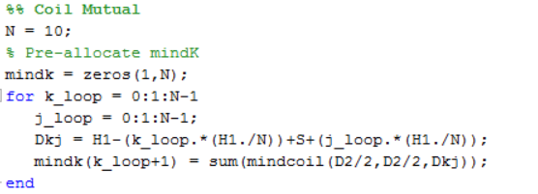

Figure 10: Mutual Inductance

To calculate the total self-inductance the self-inductance of each element is added together to provide a total self-inductance of **0.03H**.

# **Question 6**

*A constant pitch thin helical coil is made from a length L of round conductor having a copper core with diameter d and covered with an insulation of thickness t, by winding the conductor on a mandrel having a length Lm and a diameter dm ad allowing equal length leads for connection at the two ends, each with a length l.*

1. *Calculate the coil DC resistance if the electrical resistivity of copper is 1.72µΩcm.*

The following matlab code calculates the resistance of the coil at DC producing an answer of **17.52Ω**.

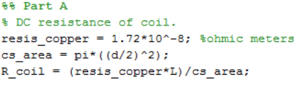

Figure 11: MATLAB Code

1. *Calculate the coil inductance*

The matlab code below calculates the coil inductance producing a value of **62.53µH**.

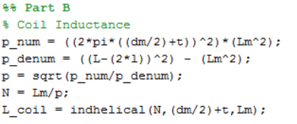

Figure 12: MATLAB Code

1. *Calculate the equivalent capacitance of the coil. The relative permeability of the conductor is $ε_{r}.$*

The matlab code below calculates the capacitance of the coil and produces a result of **0.34nF**.

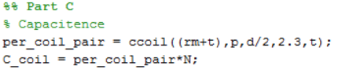

Figure 13: MATLAB Code

1. *If the coil is attached to a circuit using its leads estimate the supplementary inductance and capacitance introduced.*

The supplementary inductance and capacitance is calculated by adding working out the inductance and capaciatance for a parallel wire transmission line and produces an answer of **0.239µH** and **366pF**.

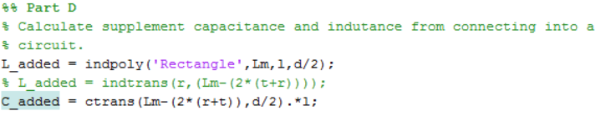

Figure 14: MATLAB Code

1. *Calculate the resonance frequency of the arrangement.*

The resonant frequency is calculated as **1.1MHz** calculated as below.

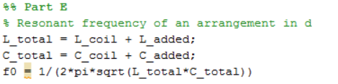

Figure 15: MATLAB Code

1. *Draw the impedance of the system with frequency up to 1GHz for the arrangement considered in d.*

The impedance characteristic with frequency is shown as below. The coil acts as a resistor at low frequency, an inductor around its resonant frequency and as a capacitor towards 1Ghz.

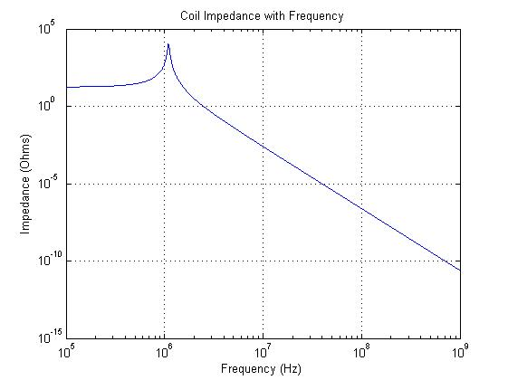

*Note:*

*All functions and code for each question can be found on www.github.com/elTomYoung/Fas-Transient-Sensors-14ELC006*